Grenada Cannabis Legalization Plan

Prepared by: Jerron Changa Roberts  
Date: April 2025

# Executive Summary

This summary outlines a strategic, evidence-based approach to legalizing cannabis in Grenada. It addresses economic potential, health safeguards, and regional leadership.

- Public Education and Legal Readiness

- Cannabis-Affiliated Business Opportunities

- Revenue Use & Reinvestment Strategy

- Global and Regional Legalization Insights

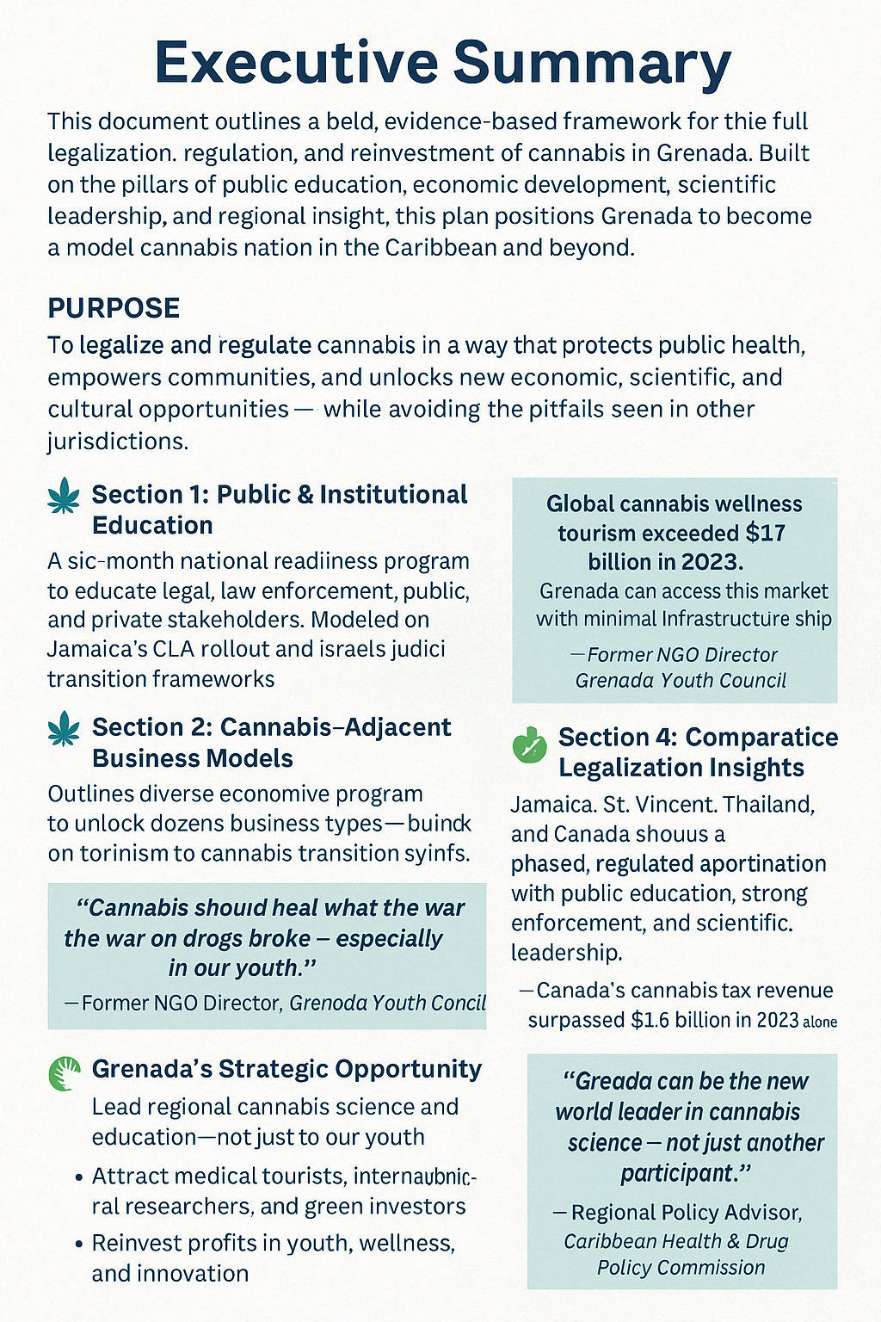

Figure 0.1: Visual Summary of Plan Pillars

# 📘 Section 1: Public & Institutional Education

A six-month framework for preparing institutions, communities, and authorities for legalization.

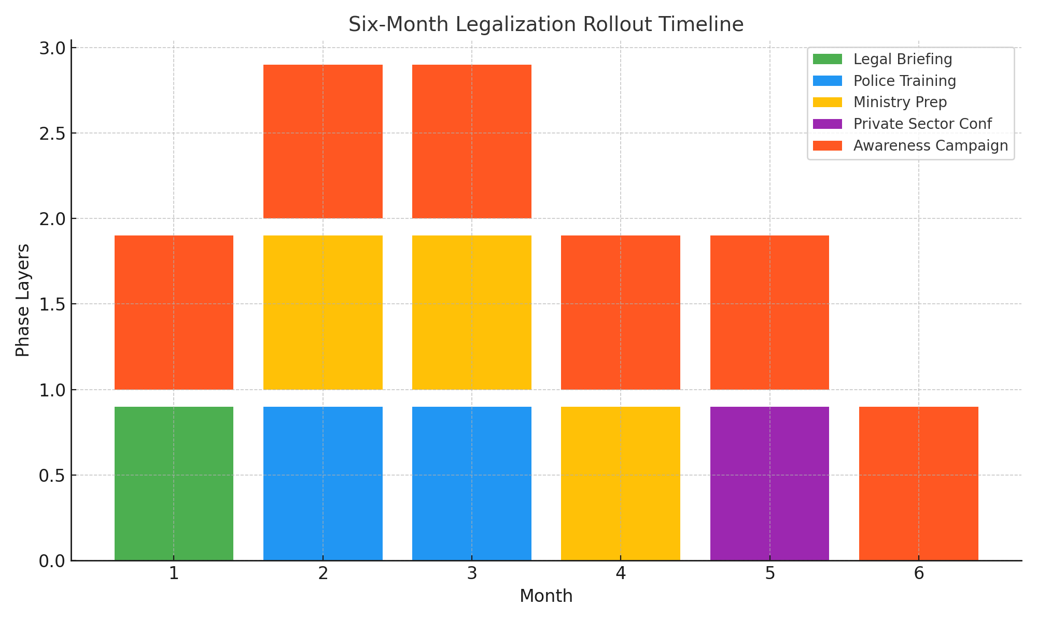

Figure 1.1: Legalization Education Rollout Timeline

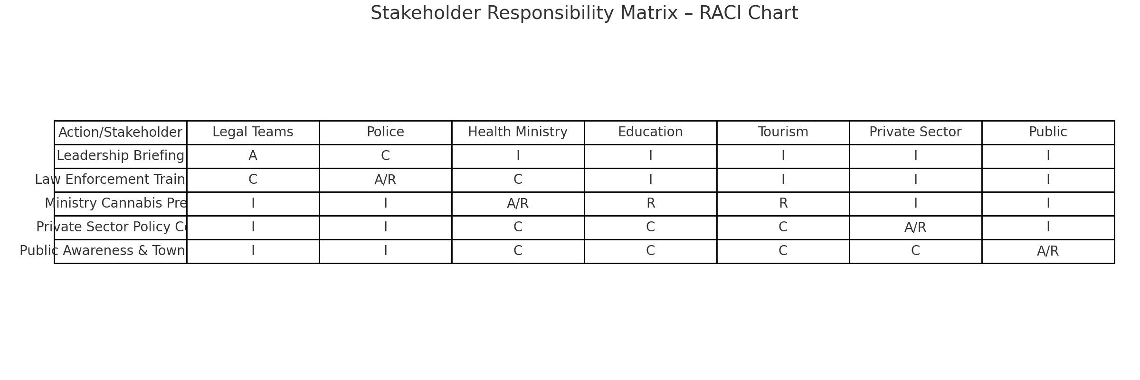

Figure 1.2: Stakeholder Responsibility Matrix

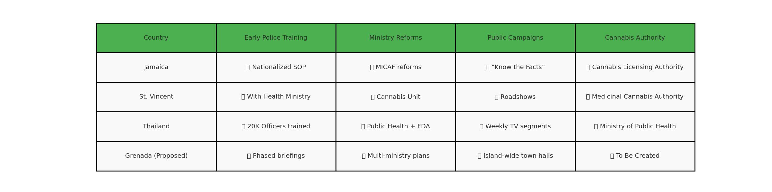

Figure 1.3: Regional Preparation Comparison Table

# 🌿 Section 2: Cannabis-Adjacent Business Models

Outlines economic opportunities in cannabis tourism, healing, and research.

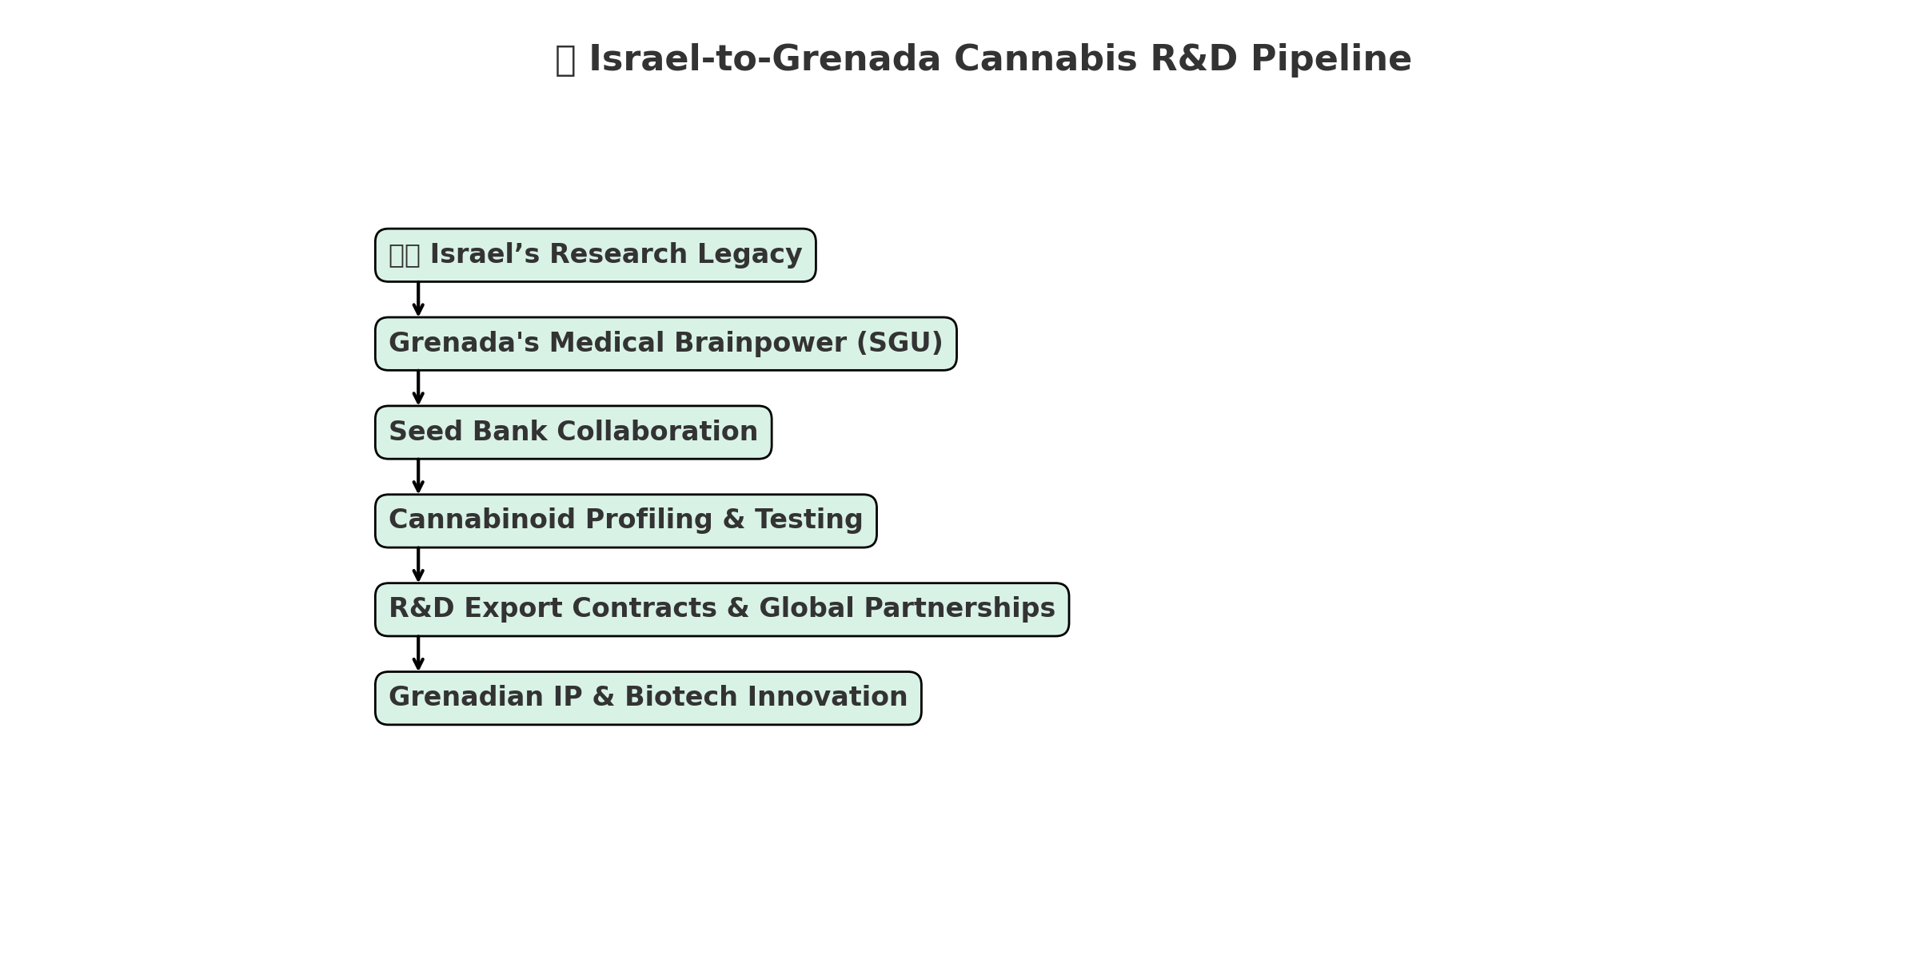

Figure 2.1: Israel-Inspired R&D Ecosystem for Grenada

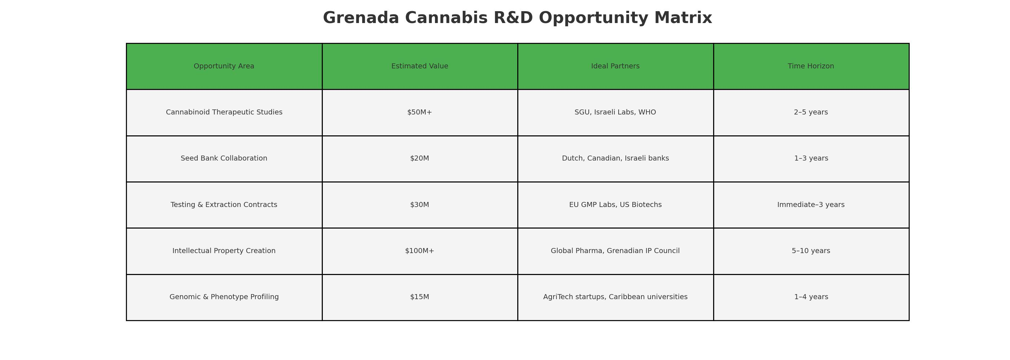

Figure 2.2: Science & Export Opportunity Matrix

# 💰 Section 3: Tax Revenue & Community Reinvestment

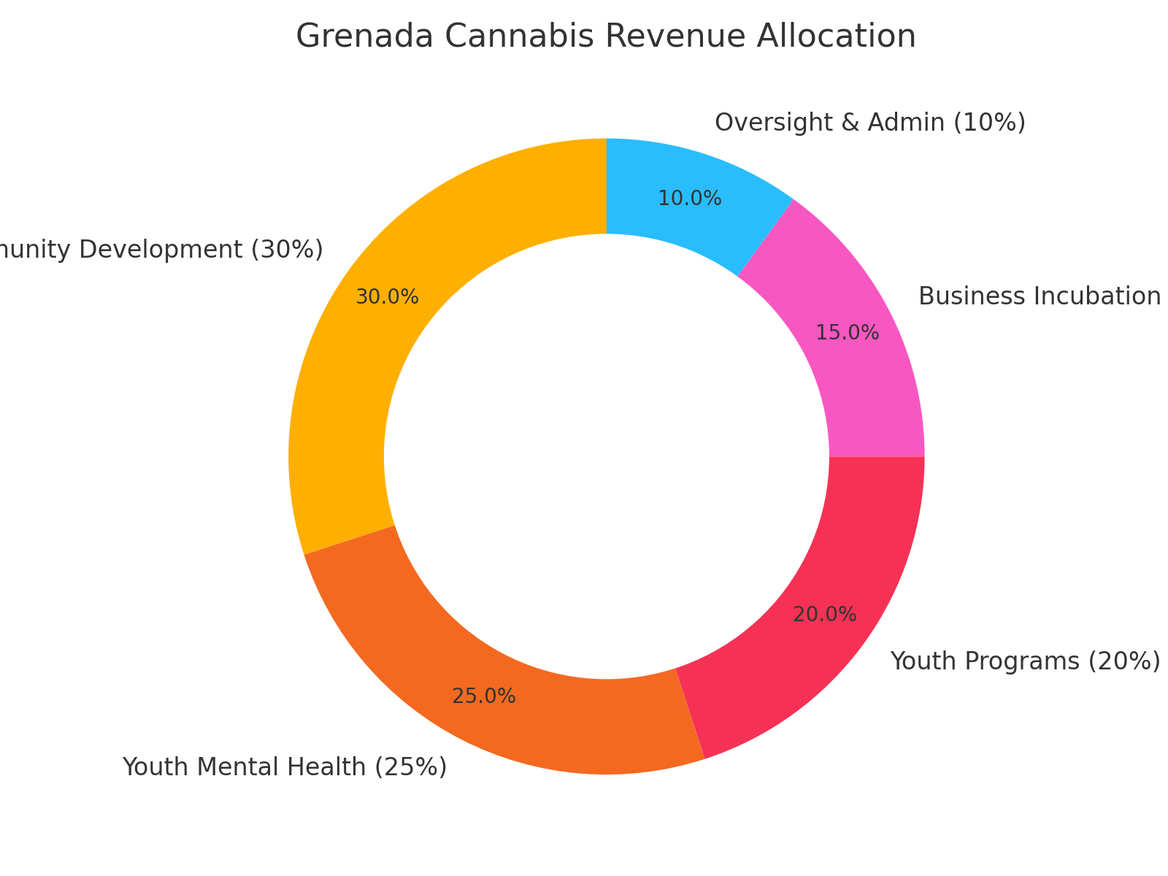

Figure 3.1: Cannabis Revenue Allocation Breakdown

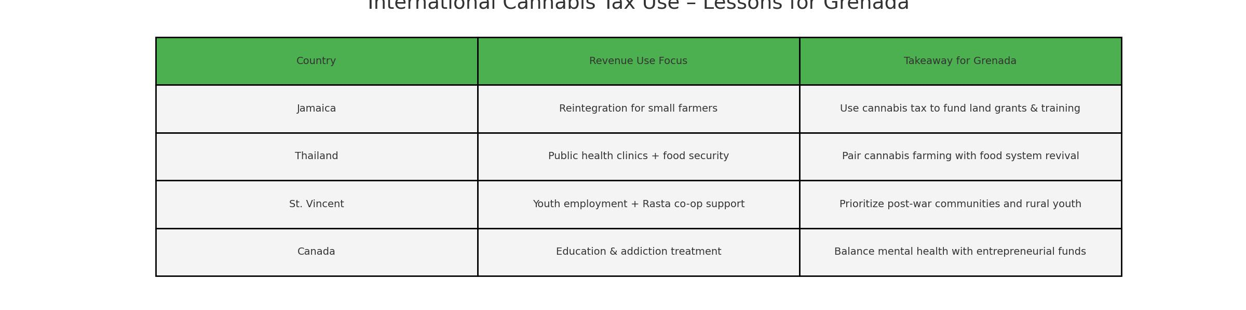

Figure 3.2: Tax Structures Across the Caribbean

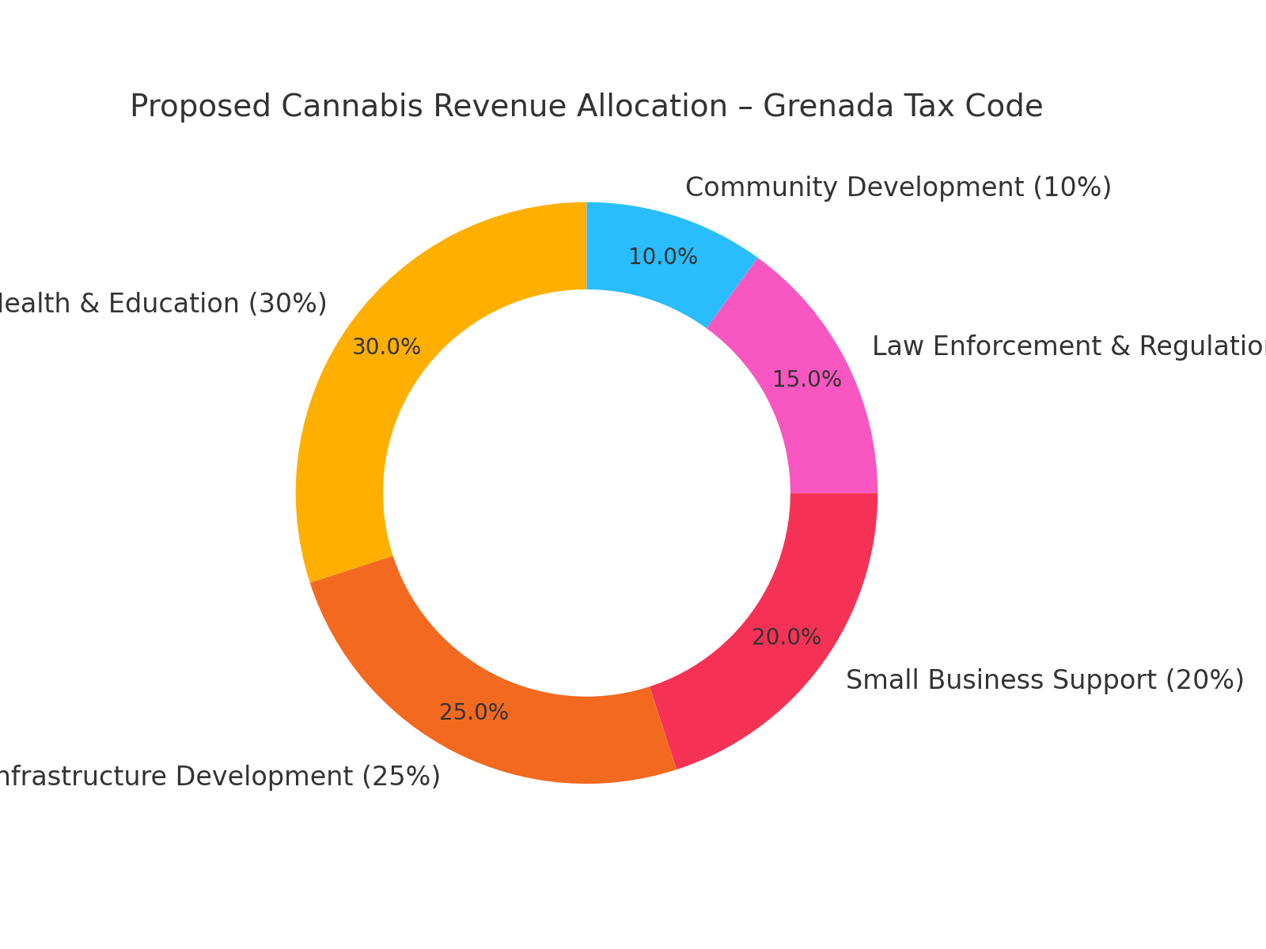

Figure 3.3: Grenada's Proposed Tax Code Allocation

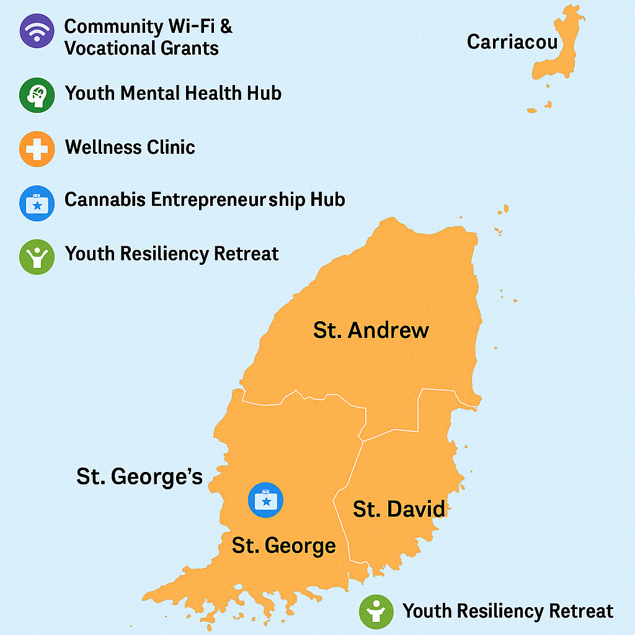

Figure 3.4: Visual Map of Revenue Usage Zones

# 🌍 Section 4: Comparative Legalization Insights

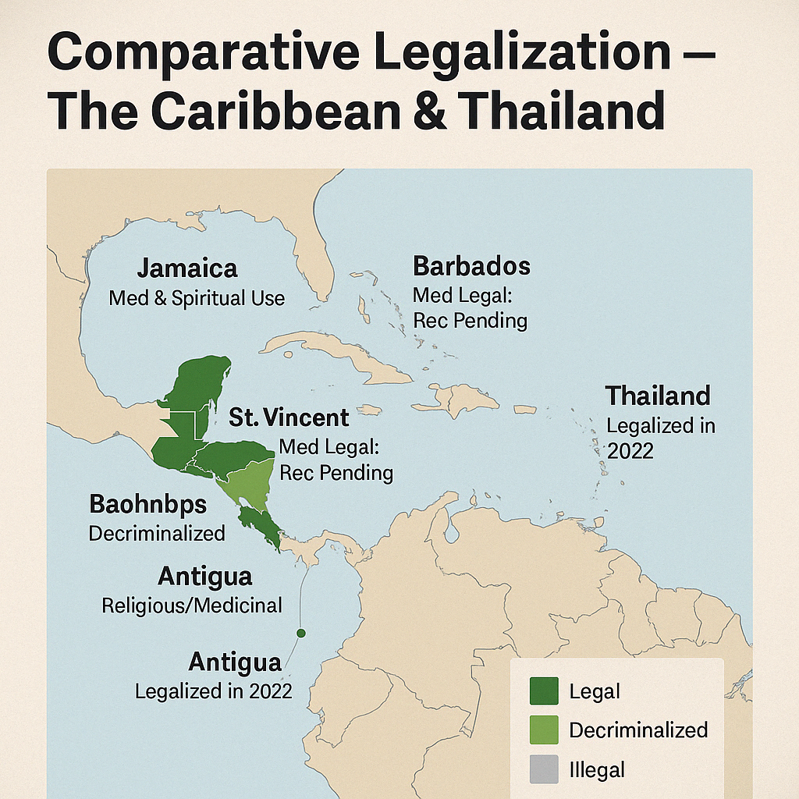

Figure 4.1: Legalization Status Map – Caribbean & Thailand

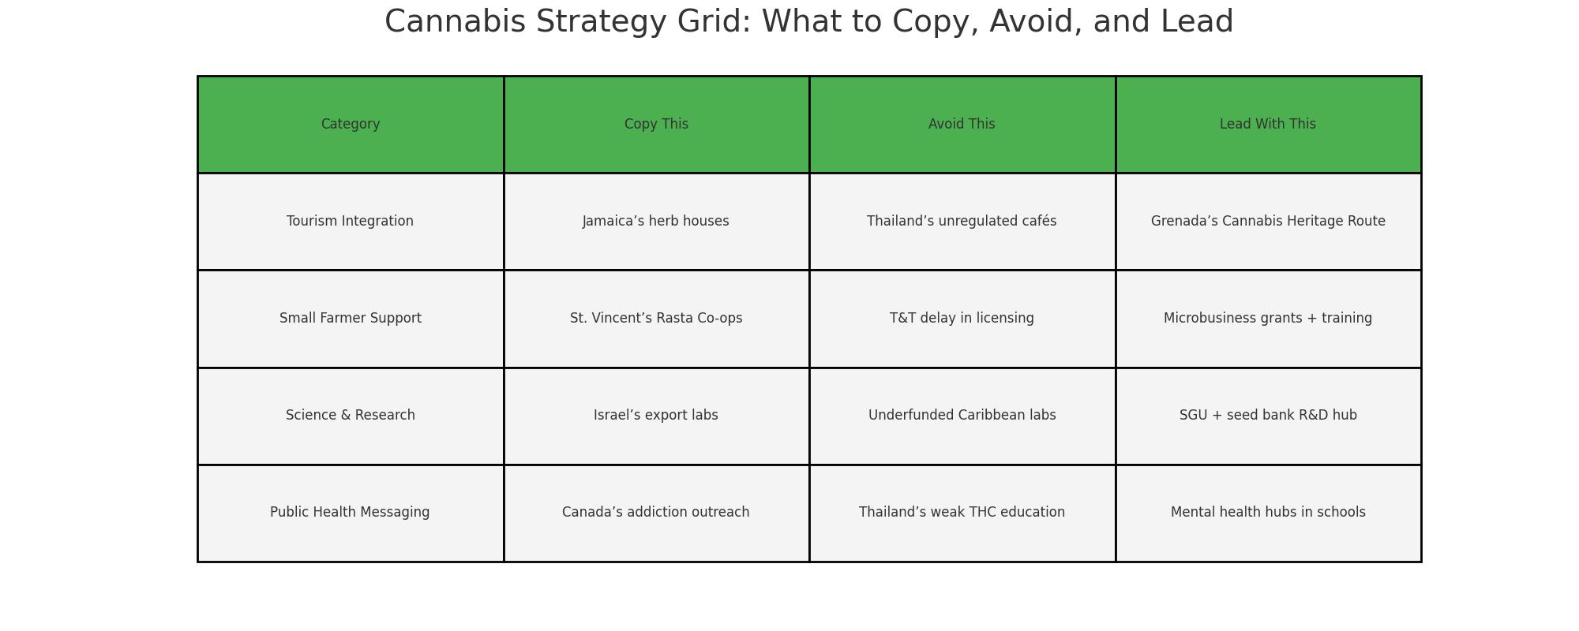

Figure 4.2: Regional Strategy Grid

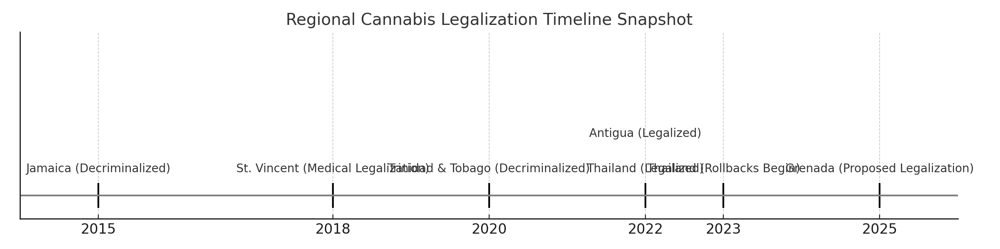

Figure 4.3: Global Timeline of Legalization Events